
Company
Logotype

Cone Beam Computed Tomography- Report



Porur Dental X-rays & CBCT

Patient Name : Mr. Tamil Vannan | Date of Report : 29.09.2024
Age/ Gender : 50 years/ Male | Region of Interest : CBCT Full Skull
Referring doctor: Dr. S. Selva Ganesh | Indication : Implant assessment
Clinical Notes: Nil
PATIENT INFORMATION

CBCT- Full Skull provided
CBCT – IMAGE DETAILS

RADIOGRAPHIC INTERPRETATION

- Completely missing crown and root portion in relation to 16, 17, 18, 26, 27, 28, 48.
- Hyperdense crown structures in relation to 31, 32, 33, 41, 42, 43.
- Presence of bone loss extending from the crestal margin upto the apical third in relation to 36, 37, 38, 46, 47.
- Presence of generalized bone loss extending beyond the middle third of teeth is evident.
- The alveolar ridge in relation to the maxillary and mandibular alveolar ridge is present with resorptive changes leading to reduced height of the mandibular ridges.

IMPLANT ASSESSMENT

 | 16 region | 17 region | 26 region | 27 region
Sub-Crestal (in mm) | 7.8 | - | 8.3 | 10.5
Mid- Crestal (in mm) | 9.3 | - | 10.8 | 11.6
Distance between the alveolar ridge and floor of the maxillary sinus (in mm) | 4.7 | 2.1 | 5.7 | 5.3

 | 36 region | 37 region | 46 region | 47 region
Sub-Crestal (in mm) | 11.7 | 11.7 | 11.9 | 12
Mid- Crestal (in mm) | 11.9 | 12.6 | 13.2 | 13.9
Distance between alveolar ridge and the inferior alveolar nerve canal (in mm) | 13.2 | 8.9 | 12.5 | 8.4
Distance between alveolar ridge and the inferior border of mandible (in mm) | 24.1 | 19.8 | 23.5 | 18.1

RADIOGRAPHIC IMPRESSION

- Partially edentulous maxillary and mandibular arch.
- Crown in relation to 31, 32, 33, 41, 42, 43.
- Generalized chronic periodontitis.

Kindly correlate with clinical findings


IMAGES FOR REFERENCE

RECONSTRUCTED PANORAMIC VIEW

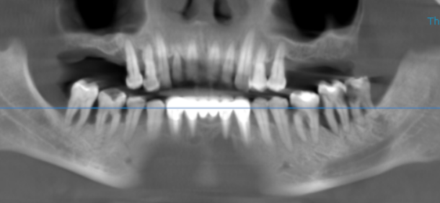

3-DIMENSIONAL VIEW

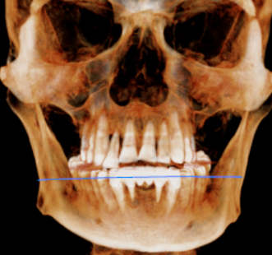

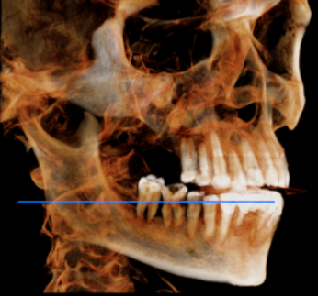
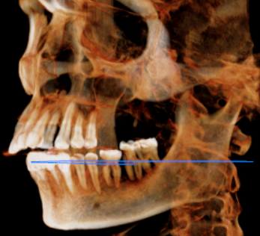

CROSS SECTIONAL VIEW

16 region | 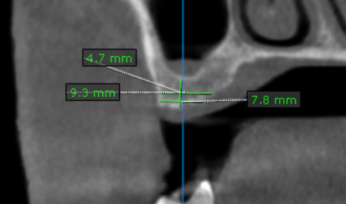
17 region | 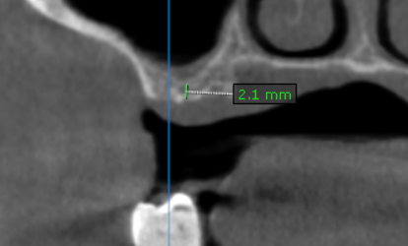
26 region | 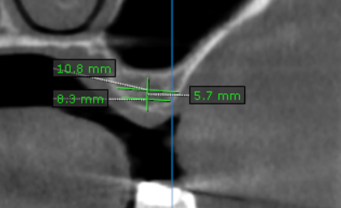
27 region | 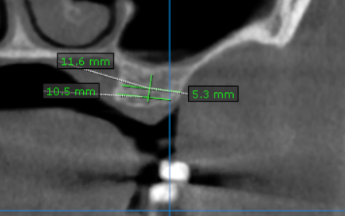
36 region | 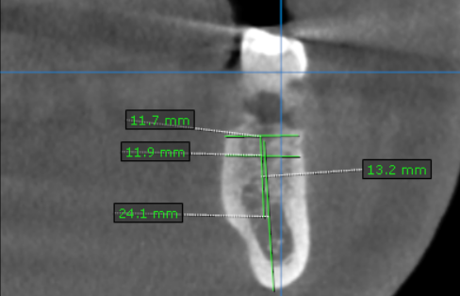
37 region | 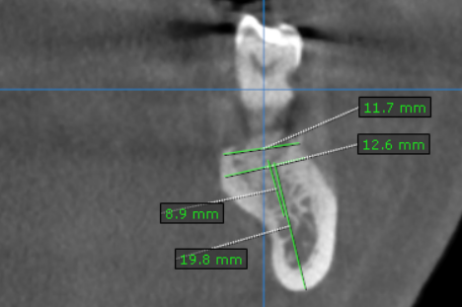
46 region | 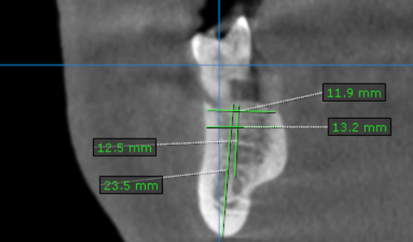
47 region | 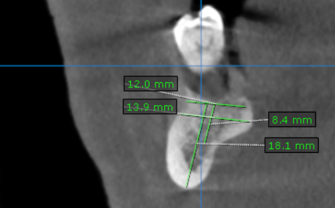

**** End of report ****

